### Female Sexual Dysfunction

### 

**Persistent, recurrent problems with sexual response, desire, orgasm, or pain — that distress you or strain your relationship with your partner — are known medically as sexual dysfunction.**

**Many women experience problems with sexual function at some point, and some have difficulties throughout their lives. Female sexual dysfunction can occur at any stage of life. It can occur only in certain sexual situations or in all sexual situations.**

**Sexual response involves a complex interplay of physiology, emotions, experiences, beliefs, lifestyle, and relationships. Disruption of any component can affect sexual desire, arousal, or satisfaction, and treatment often involves more than one approach.**

#### ****What are the most common symptoms?****

**Symptoms vary depending on what type of sexual dysfunction you’re experiencing:**

* **Low sexual desire. This most common of female sexual dysfunctions involves a lack of sexual interest and willingness to be sexual.**
* **Sexual arousal disorder. Your desire for sex might be intact, but you have difficulty with arousal or are unable to become aroused or maintain arousal during sexual activity.**
* **Orgasmic disorder. You have persistent or recurrent difficulty in achieving orgasm after sufficient sexual arousal and ongoing stimulation.**
* **Sexual pain disorder. You have pain associated with sexual stimulation or vaginal contact.**



#### ****When to see a doctor?****

**If sexual problems affect your relationship or worry you, make an appointment with your doctor for evaluation.**

#### ****Causes****

**Sexual problems often develop when your hormones are in flux, such as after having a baby or during menopause. Major illnesses, such as cancer, diabetes, or heart and blood vessel (cardiovascular) disease, can also contribute to sexual dysfunction.**

**Factors — often interrelated — that contribute to sexual dissatisfaction or dysfunction include:**

* **Physical. Any number of medical conditions, including cancer, kidney failure, multiple sclerosis, heart disease and bladder problems, can lead to sexual dysfunction. Certain medications, including some antidepressants, blood pressure medications, antihistamines and chemotherapy drugs, can decrease your sexual desire and your body’s ability to experience orgasm.**
* **Hormonal. Lower estrogen levels after menopause may lead to changes in your genital tissues and sexual responsiveness. A decrease in estrogen leads to decreased blood flow to the pelvic region, which can result in less genital sensation, as well as needing more time to build arousal and reach orgasm.**

**The vaginal lining also becomes thinner and less elastic, particularly if you’re not sexually active. These factors can lead to painful intercourse (dyspareunia). Sexual desire also decreases when hormonal levels decrease.**

**Your body’s hormone levels also shift after giving birth and during breastfeeding, which can lead to vaginal dryness and can affect your desire to have sex.**

* **Psychological and social. Untreated anxiety or depression can cause or contribute to sexual dysfunction, as can long-term stress and a history of sexual abuse. The worries of pregnancy and the demands of being a new mother may have similar effects.**

**Long-standing conflicts with your partner — about sex or other aspects of your relationship — can diminish your sexual responsiveness as well. Cultural and religious issues and problems with body image also can contribute.**

#### ****Risk factors****

**Some factors may increase your risk of sexual dysfunction:**

* **Depression or anxiety**
* **Heart and blood vessel disease**
* **Neurological conditions, such as spinal cord injury or multiple sclerosis**
* **Gynecological conditions, such as vulvovaginal atrophy, infections, or lichen sclerosis**
* **Certain medications, such as antidepressants or high blood pressure medications**
* **Emotional or psychological stress, especially with regard to your relationship with your partner**
* **A history of sexual abuse**

#### ****Diagnosis****

**To diagnose female sexual dysfunction, your doctor may:**

* **Discuss your sexual and medical history. You might be uneasy talking with your doctor about such personal matters, but your sexuality is a key part of your well-being. The more upfront you can be about your sexual history and current problems, the better your chances of finding an effective way to treat them.**
* **Perform a pelvic exam. During the exam, your doctor checks for physical changes that affect your sexual enjoyment, such as thinning of your genital tissues, decreased skin elasticity, scarring or pain.**
* **Order blood tests. Your doctor may recommend blood tests to check for underlying health conditions that might contribute to sexual dysfunction.**

**Your doctor may also refer you to a counselor or therapist specializing in sexual and relationship problems.**

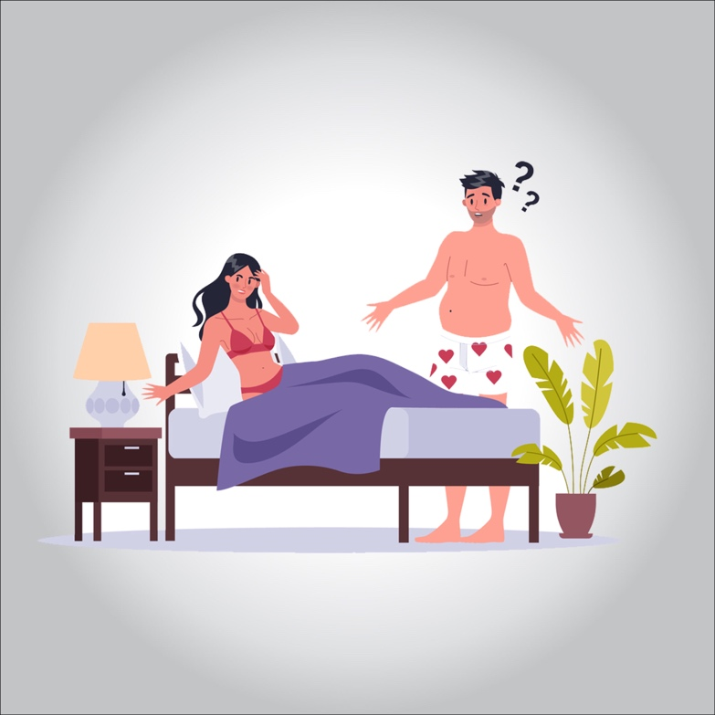

#### ****Treatment****

**Keep in mind that sexual dysfunction is a problem only if it bothers you. If it doesn’t bother you, there’s no need for treatment.**

**Because female sexual dysfunction has many possible symptoms and causes, treatment varies. It’s important for you to communicate your concerns, as well as to understand your body and its normal sexual response. Also, your goals for your sex life are important for choosing a treatment and evaluating whether or not it’s working for you.**

**Women with sexual concerns most often benefit from a combined treatment approach that addresses medical as well as relationship and emotional issues.**

#### ****Nonmedical treatment for female sexual dysfunction****

**To treat sexual dysfunction, your doctor might recommend that you start with these strategies:**

* **Talk and listen. Open communication with your partner makes a world of difference in your sexual satisfaction. Even if you’re not used to talking about your likes and dislikes, learning to do so and providing feedback in a nonthreatening way sets the stage for greater intimacy.**
* **Practice healthy lifestyle habits. Limit alcohol — drinking too much can blunt your sexual responsiveness. Be physically active — regular physical activity can increase your stamina and elevate your mood, enhancing romantic feelings. Learn ways to decrease stress so you can focus on and enjoy sexual experiences.**
* **Seek counseling. Talk with a counselor or therapist who specializes in sexual and relationship problems. Therapy often includes education about how to optimize your body’s sexual response, ways to enhance intimacy with your partner, and recommendations for reading materials or couples exercises.**
* **Use a lubricant. A vaginal lubricant may be helpful during intercourse if you have vaginal dryness or pain during sex.**
* **Try a device. Arousal may be enhanced with stimulation of the clitoris. Use a vibrator to provide clitoral stimulation.**

#### ****Medical treatment for female sexual dysfunction****

**Effective treatment for sexual dysfunction often requires addressing an underlying medical condition or hormonal change. Your doctor may suggest changing a medication you’re taking or prescribing a new one.**

**Treating female sexual dysfunction linked to a hormonal cause might include:**

* **Estrogen therapy. Localized estrogen therapy comes in the form of a vaginal ring, cream, or tablet. This therapy benefits sexual function by improving vaginal tone and elasticity, increasing vaginal blood flow, and enhancing lubrication.**

**The risks of hormone therapy may vary depending on your age, your risk of other health issues such as heart and blood vessel disease and cancer, the dose and type of hormone, and whether estrogen is given alone or with a progestin.**

**Talk with your doctor about the benefits and risks. In some cases, hormonal therapy might require close monitoring by your doctor.**

* **Ospemifene (Osphena). This medication is a selective estrogen receptor modulator. It helps reduce pain during sex for women with vulvovaginal atrophy.**
* **Androgen therapy. Androgens include testosterone. Testosterone plays a role in healthy sexual function in women as well as men, although women have much lower levels of testosterone.**

**Androgen therapy for sexual dysfunction is controversial. Some studies show a benefit for women who have low testosterone levels and develop sexual dysfunction; other studies show little or no benefit.**

* **Flibanserin (Addyi). Originally developed as an antidepressant, flibanserin is approved by the Food and Drug Administration as a treatment for low sexual desire in premenopausal women.**

**A daily pill, Addyi may boost sex drive in women who experience low sexual desire and find it distressing. Potentially serious side effects include low blood pressure, sleepiness, nausea, fatigue, dizziness and fainting, particularly if the drug is mixed with alcohol. Experts recommend that you stop taking the drug if you don’t notice an improvement in your sex drive after eight weeks.**

#### ****Potential treatments that need more research****

**More research is needed before these agents might be recommended for treatment of female sexual dysfunction:**

* **Tibolone. Tibolone is a synthetic steroid drug used in Europe and Australia for the treatment of postmenopausal osteoporosis. Due to concerns over the increased risk of breast cancer and stroke in women taking tibolone, the drug isn’t approved by the Food and Drug Administration for use in the U.S.**
* **Phosphodiesterase inhibitors. This group of medications has proved successful in treating erectile dysfunction in men, but the drugs don’t work nearly as well in treating female sexual dysfunction. Studies looking into the effectiveness of these drugs in women show inconsistent results.**

**One drug, sildenafil (Revatio, Viagra), may prove beneficial for some women who have sexual dysfunction as a result of taking selective serotonin reuptake inhibitors (SSRIs), a class of drugs used to treat depression. Don’t take sildenafil if you use nitroglycerin for angina — a type of chest pain caused by reduced blood flow to the heart.**

**Issues surrounding female sexual dysfunction are usually complex, so even the best medications aren’t likely to work if other emotional or social factors remain unresolved.**

#### 

#### ****Lifestyle and home remedies****

**To boost your sexual health, find ways to be comfortable with your sexuality, improve your self-esteem and accept your body. Try practicing these healthy lifestyle habits:**

* **Avoid excessive alcohol. Drinking too much blunts sexual responsiveness.**
* **Don’t smoke. Cigarette smoking restricts blood flow throughout your body. Less blood reaches your sexual organs, which means you could experience decreased sexual arousal and orgasmic response.**
* **Be physically active. Regular aerobic exercise increases your stamina, improves your body image, and elevates your mood. This can help you feel more romantic, more often.**
* **Make time for leisure and relaxation. Learn ways to decrease stress, and allow yourself to relax amid the stresses of your daily life. Being relaxed can enhance your ability to focus on your sexual experiences and may help you attain more satisfying arousal and orgasm.**